The Knights Table Project Management Plan

Tim Adams, Chris Lucas, Tyler Sancibrian, Tony Burke

Version 1.2

October 23, 2019

**Table of Contents**

Description: 2

Objective: 2

Scope: 3

Timeframe: 3

Milestone List 6

Project Budget: 8

Infrastructure 8

Monitoring and Evaluation: 8

# Description:

The Knight's Party Table is a two-person video game table that will play games against one another.

# Objective:

The main objective of the project is to implement a new input system and install new games onto the table. The games right now that are on the agenda are checkers, chess, battleship, and Catan. More will be added when the come up. The games we plan on implementing at this current time are the following:

* Battleship
* Checkers
* Chess
* Settlers of Catan

More games will be added if the project is completed at a rate more efficient than expected.

# Scope:

The Scope of the Party Table includes: Planning the Project, Designing what the project will look like in its final form, Developing the code, Removing/Replacing the physical computer and outer casing, and Testing the code with the computer to make sure the inputs work properly without issue.

# Timeframe:

The table needs to be pass all test cases and include all of the given games by May 15, 2019. The following is a Gantt Chart and Work Breakdown Structure detailing the schedule of the project that clearly display the start and end dates as well as the time each aspect of the project will take.

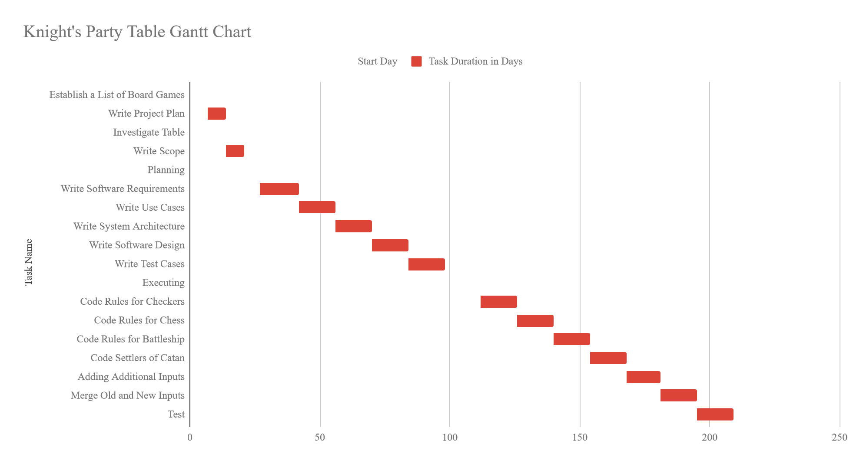

|  |  |  |
| --- | --- | --- |
| **Task Name** | **Start Date** | **End Date** |
| **Initiating** |  |  |
| Establish a List of Board Games | 9/11/2019 | 9/11/2019 |
| Write Project Plan | 9/18/2019 | 9/25/2019 |
| Investigate Table | 9/30/2019 | 9/30/2019 |
| Write Scope | 9/25/2019 | 10/2/2019 |
|  |  |  |
|  |  |  |
| **Planning** |  |  |
| Write Software Requirements | 10/8/2019 | 10/23/2019 |
| Write Use Cases | 10/23/19 | 11/6/2019 |
| Write System Architecture | 11/6/19 | 11/20/2019 |
| Write Software Design | 11/20/2019 | 12/4/2019 |
| Write Test Cases | 12/4/2019 | 12/18/2019 |
|  |  |  |
| **Executing** |  |  |
| Code Rules for Checkers | 1/1/2020 | 1/15/20 |
| Code Rules for Chess | 1/15/2020 | 1/29/2020 |
| Code Rules for Battleship | 1/29/2020 | 2/12/2020 |
| Code Settlers of Catan | 2/12/2020 | 2/26/2020 |
| Adding more inputs to both players | 2/26/2020 | 3/10/2020 |
| Fix PC inputs to work with the new ones | 3/10/2020 | 3/24/2020 |
| Test | 3/24/2020 | 4/7/2020 |
|  |  |  |
| **Monitoring and Controlling** |  |  |
|  |  |  |
| **Closing** |  | 5/15/2020 |

# 

# 

# Milestone List:

The following is a list of milestones needed to complete the project and their due dates.

|  |  |  |
| --- | --- | --- |
| **Milestone** | **Description** | **Due Date** |
| Establish a List of Board Games | Create a list of board games that will be implemented. | 9/11/2019 |
| Write Project Plan | Create a management plan for the Knight’s Party Table Project. | 9/25/2019 |
| Investigate Table | Review the current status of the Knight’s Party Table hardware. | 9/30/2019 |
| Write Scope | Create a project scope for the Knight’s Party Table Project. | 10/2/2019 |
| Write Software Requirements | Write the software requirements documents for all of the games. | 10/23/2019 |
| Write Use Cases | Write the software use cases for all of the games. | 11/6/2019 |
| Write System Architecture | Write the system architecture for the Knight’s Party Table. | 11/20/2019 |
| Write Software Design | Write the software design document for the Knight’s Party Table. | 12/4/2019 |
| Write Test Cases | Write the test cases used to test the Knight’s Party Table. | 12/18/2019 |
| Code Rules for Checkers | Write the Java code for Checkers rules. | 1/15/2019 |
| Code Rules for Chess | Write the Java code for Chess rules. | 1/29/2019 |
| Code Rules for Battleship | Write the Java code for Battleship rules. | 2/12/2019 |
| Code Settlers of Catan | Write the Java code for Settlers of Catan. | 2/26/2019 |
| Adding more inputs to both players | Add more hardware input methods for players. | 3/10/2019 |
| Fix PC inputs to work with the new ones | Fix the hardware inputs on the Knight’s Party Table to work with the previously installed input. | 3/24/2019 |
| Test | Ensure the Knight’s Party Table passes all test cases. | 4/7/2019 |

# Project Budget:

We will need new buttons and possibly other hardware that we do not know the budget at this time.

# Infrastructure

Infrastructure is an important aspect to the project. For our project, we will use a GitHub repository to manage, monitor, and store our Java code, as well as to track and manage bugs (or as we like to refer to them, features). We will use the Waterfall method of code development - starting with requirements, then architecture, followed by coding and testing.

# Monitoring and Evaluation:

In order to ensure timeliness and the project’s successful completion, weekly team check-ins will be performed. This will keep the team on schedule and guarantee timely completion of project deliverables.